Name

Mathematics Stage 4
Ratios

Book 1 | Simplify ratios  Solve problems involving ratios | Version: 260827  Feedback:  https://MrDingMaths.com
Contents
Syllabus Content 2
Representing Ratios 4
Equivalent Ratios 11
Simplifying Ratios 13
Simplifying Ratios with Fractions and Decimals 18
Solving Problems using Equivalent Ratios 24
Finding Lengths in Scale Drawings 27
Ratio Problems using the Unitary Method 35
Solving Ratio Problems using Equivalent Fractions 39
Dividing in a Ratio 41
Mixed Applications 48
Challenge Exercise 53

Syllabus Content
MA4-RAT-C-01 solves problems involving ratios and rates, and analyses distance–time graphs
Recognise and simplify ratios
- Use ratios to compare 2 or more quantities measured in the same units
- Identify and express one part of a ratio as a fraction of the whole
- Simplify ratios
Solve problems involving ratios
- Apply the unitary method to solve ratio problems
- Divide a quantity in a given ratio
- Solve real-life problems involving ratios

Representing Ratios

- Ratios Compare Quantities
A ratio is a relationship between two or more quantities.
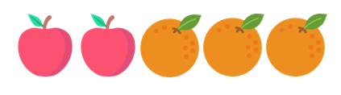
Example: 2 apples for every 3 oranges.
The ratio of apples to oranges is 2 to 3.
apples : oranges = $2 :3$
Part : part ratio compares two parts of a whole.
Part : whole ratio compares a part to the whole.
Part : Part  apples : oranges  2 : 3 | Part : Whole  apples : all fruit  2 : 5

- Identify Ratio
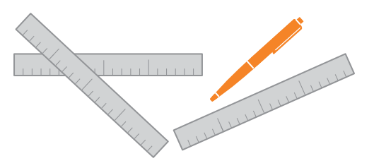  Pens to rulers …………  Rulers to pens …………  Rulers to all stationery ………… | - There are 4 boys and 5 girls in a group  Boys to girls ………  Girls to boys ………  Girls to all children …………
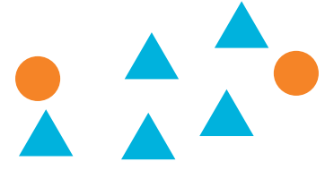  Circles to triangles  Triangles to circles  Circles to all shapes |   Circles to squares  Triangles to circles  Squares to circles to triangles  Triangles to all shapes

- Key Ideas
- A ratio shows a relationship between two ……………………………
- A ratio can relate two …………… or relate a part to the whole.
- The ratio 3:7 is read as: “three ……… seven.”
- 3:7 is ……………………… to 7:3.
- Ratios as Fractions
Part : Part  apples : oranges  2 : 3  apples are $\frac{2}{3}$ of oranges | Part : Whole  apples : all fruit  2 : 5  apples are $\frac{2}{5}$ of all fruit

- Example Represent a ratio as a fraction
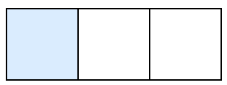  Shaded to unshaded as a ratio: 1:2  Shaded to unshaded as a fraction: $\frac{1}{2}$  Shaded to all squares as a ratio: 1:3  Shaded as a fraction of the whole: $\frac{1}{3}$ | part:part compares a part to another ………  part:whole compares a part to the …………  True or false? A fraction always represents parts of a whole.  …………, a fraction can also represent a part:part ratio.

- Guided Practice
Shaded to unshaded as a ratio:  1 : 3 | Shaded to unshaded as a fraction:  $$\frac{1}{3}$$
Shaded to the whole as a ratio:  1 : 4 | Shaded to the whole as a fraction:  $$\frac{1}{4}$$

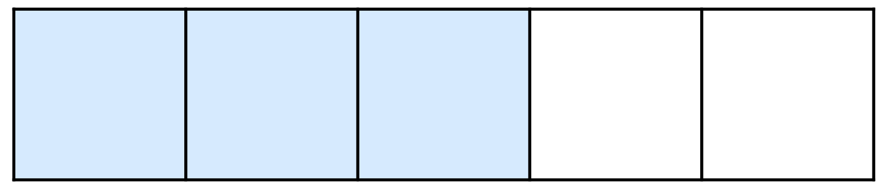

Shaded to unshaded as a ratio:  3 : 2 | Shaded to unshaded as a fraction:  $$\frac{3}{2}$$
Shaded to the whole as a ratio:  3 : 5 | Shaded to the whole as a fraction:  $$\frac{3}{5}$$

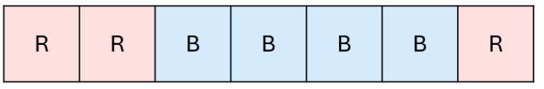

Blue to red as a ratio:  4 : 3 | Blue to red as a fraction:  $$\frac{4}{3}$$
Blue to the whole as a ratio:  4 : 7 | Blue to the whole as a fraction  $$\frac{4}{7}$$

Foundation
- Compare these quantities using ratio notation.
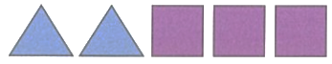  $Squares :Triangles$  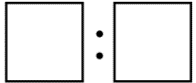  3:2  $Triangles :Squares$  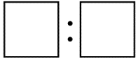  2:3  $Triangles :Shapes$  2:5  $Squares :Shapes$  3:5 | 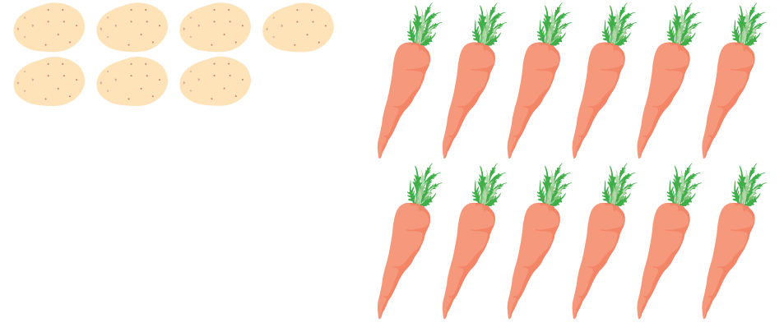  $Carrots :Potatoes$  6:7  $Potatoes :Carrots$  7:6  $Carrots :Vegetables$  6:13  $Potatoes :Vegetables$  7:13
  $Circles :Squares$  6:5  $Squares :Circles$  5:6  $Circles :Total$  6:11  $Squares :Total$  5:11  Circles is of the total.  $$\frac{6}{11}$$  Squares is of the total.  $$\frac{5}{11}$$ | 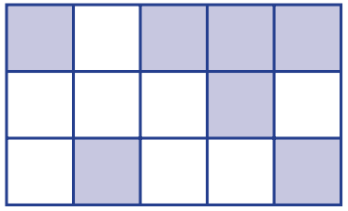  $Shaded :Unshaded$  7:8  $Unshaded :Shaded$  8:7  $Shaded :Total$  7:15  $Unshaded :Total$  8:15  Shaded is of the total.  $$\frac{7}{15}$$  Unshaded is of the total.  $$\frac{8}{15}$$

- There are 3 apples and 4 bananas in a bowl.
  - What fraction of the total are bananas?
$$\frac{4}{7}$$
  - What is the ratio of bananas to apples?
4:3
  - What is the ratio of apples to total fruits?
3:7

- A box contains 5 green and 7 red marbles.
  - Write the ratio of green marbles to red marbles.
5:7
  - What is the total number of marbles?
12
  - What fraction of the marbles are green?
$$\frac{5}{12}$$

- Over 14 days, it rained on 8 days, snowed on 3 days, and was fine the rest. Write the ratio of:
- Rainy days to snowy days.  8:3 | - Snowy days to total days.  3:14
- Fine days to rainy days.  3:8 | - Fine days as a fraction of the fortnight.  $$\frac{3}{14}$$
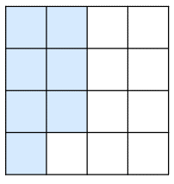
- Consider the diagram.
  - What is the ratio of shaded : unshaded?
7:9
  - Emily says the shaded parts as a fraction of the whole is $\frac{7}{9}$.
Explain why she is incorrect.

The part to whole ratio would be 7:16 or $\frac{7}{16}$

- The fraction of a class that are boys is $\frac{3}{5}$.
  - What fraction of the class are girls?
$$\frac{2}{5}$$
  - Eddie says that the ratio of boys to girls is $3:5$.
Explain why he is incorrect and state the correct ratio of boys to girls.

3:5 is the ratio of boys to all students. The ratio of boys to girls is 3:2.

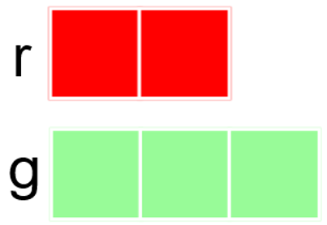
Development
- The ratio of red to green is $2:3$.

Green is of the total.  $$\frac{3}{5}$$ | Red is of green.  $$\frac{2}{3}$$ | Green is of red.  $$\frac{3}{2}$$

- Convert between these ratios and fractions.
- The ratio of $a:b$ is 3 : 2  $a$ is of the total.  $$\frac{3}{5}$$ | - The ratio of $a:b$ is 2 : 8  $a$ is of $b$.  $$\frac{2}{8} or \frac{1}{4}$$
- The ratio of $a:b$ is 3 : 2  $b$ is of the total.  $$\frac{2}{5}$$ | - The ratio of $a:b$ is 3 : 9  $a$ is of $b$.  $$\frac{3}{9} or \frac{1}{3}$$
- The ratio of $a:b$ is 3 : 1  $b$ is of the total.  $$\frac{1}{4}$$ | - The ratio of $a:b$ is 3 : 10  $a$ is of $b$.  $$\frac{3}{10}$$
- The ratio of $a:b$ is 3 : 2  $b$ is of $a$.  $$\frac{2}{3}$$ | - The ratio of $a:b$ is 3 : 10  $b$ is of $a$.  $$\frac{10}{3}$$
- The ratio of $a:b$ is 4 : 1  $b$ is of $a$.  $$\frac{1}{4}$$ | - The ratio of $a:b$ is 3 : 10  $a$ is of the total.  $$\frac{3}{13}$$
- The ratio of $a:b$ is 4 : 1  $a$ is of $b$.  $$\frac{4}{1} or 4$$ | - The ratio of $a:b$ is 3 : 10  $b$ is of the total.  $$\frac{10}{13}$$
- The ratio of $a:b$ is 8 : 2  $a$ is of $b$.  $$\frac{8}{2} or 4$$ | - The ratio of $a:b$ is 10 : 3  $b$ is of the total.  $$\frac{3}{13}$$

Mastery
- Jacob is making a drink using cordial and water.
For every one part cordial, he uses four parts water.
  - Write the ratio of cordial to water.
1:4
  - Jacob makes a second drink using cordial to water in the ratio 1:5.
Will this drink be stronger or weaker than his first drink?

weaker, as there are more parts of water for each part of cordial.
  - Which of these ratios of cordial to water will make the strongest drink?
Explain your answer.
1:5 2:5 2:3 3:10

2:3, by converting all four ratios to fractions, $\frac{2}{3}$ is the largest fraction out of the four.
  - Jenny says that there must also be more of the second drink compared to the first drink. Explain why she is not correct.

a ratio tells you nothing about the total amount, only one amount related to the other.
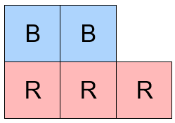
- Classify these statements true or false.
  - $\frac{2}{3}$ of the squares are blue.
false
  - $\frac{3}{5}$ of the squares are red.
true
  - The number of blue squares is $\frac{2}{3}$ of the number of red.
true
  - The number of red squares is $\frac{3}{2}$ of the number of blue.
true
  - The ratio of red squares to the total number of squares is $3:5$.
true

Equivalent Ratios

- Review
- This necklace is made up of coloured beads and white beads
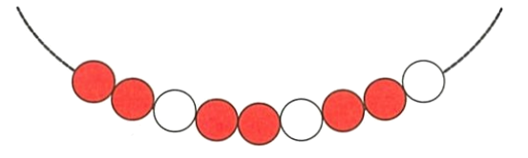

Decide whether these statements are true or false.
  - For every 6 coloured beads, there are 3 white beads. ………………
  - For every 2 coloured beads, there are 1 white bead. ………………
  - For every 1 white bead, there are 2 coloured beads ………………
  - For every 2 white beads, there is 1 coloured bead. ………………

- Write the equivalent fraction.
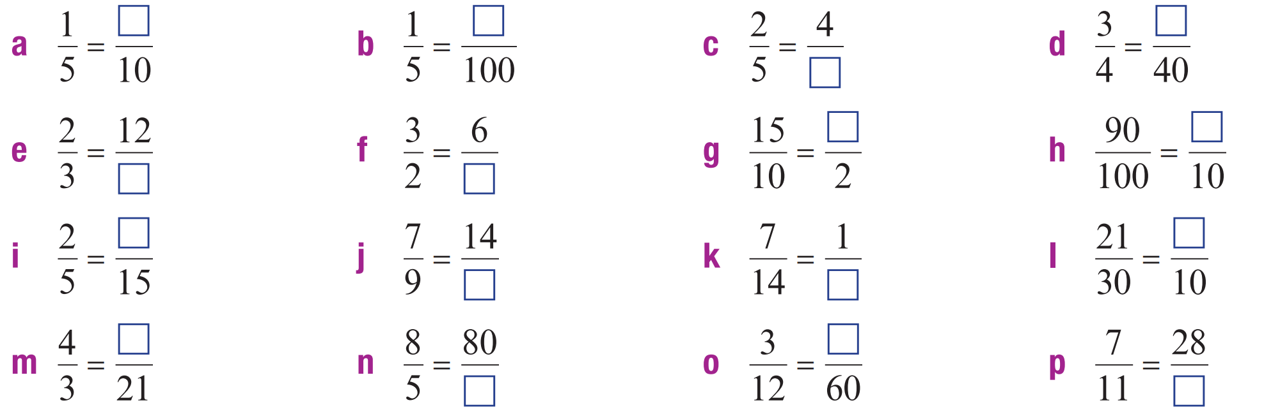

- Equivalent Ratios
Equivalent ratios show the same relationship between two quantities.
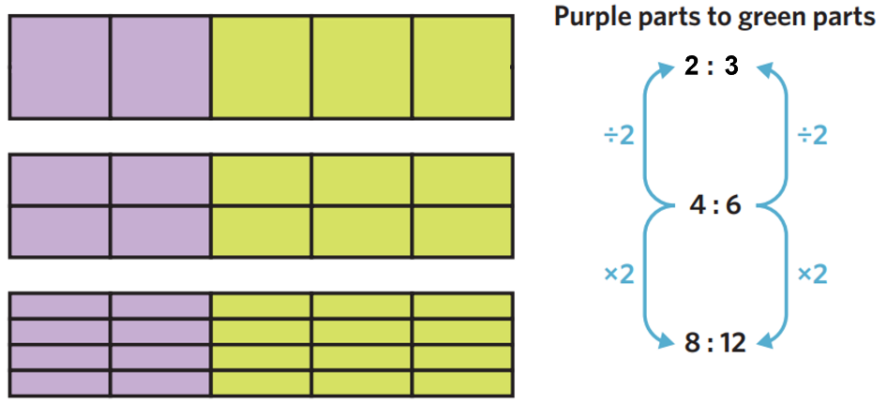
To make equivalent ratios, multiply or divide every part by the same number.

- Example Produce equivalent ratios
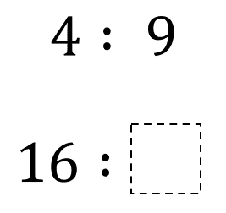  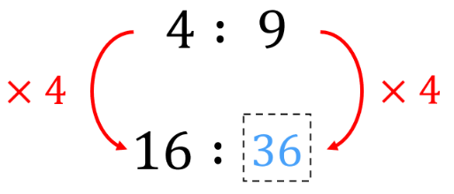 | 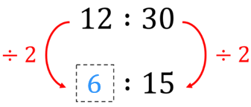  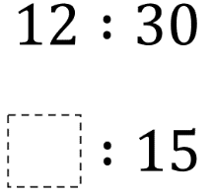

- Guided Practice
Produce these equivalent ratios.
$1 :3$  $5 :$ …  15 | $9 :10$  $27 :$ …  30
$2 :9$  … $:18$  4 | $20 :32$  … $:8$  5
$12 :15$  $4 :$ …  5 | $35 :14$  … $:2$  5

- Key Ideas
- …………………… ratios represent the same relationship between two numbers.
- To find equivalent ratios, ……………… or ……………… the two parts of the ratio by the same number.

Foundation
- Produce these equivalent ratios.
12 | 6 | 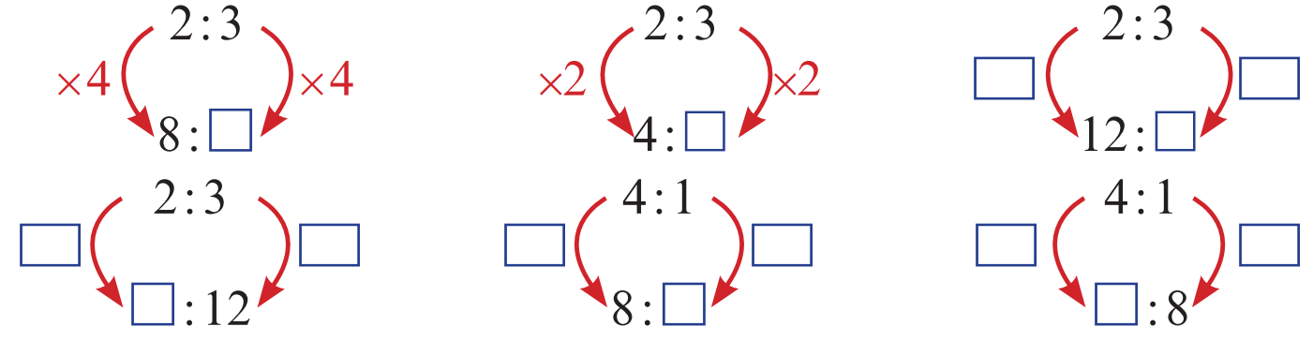  18
8 | 2 | 32

- Produce these equivalent ratios.
6 | 3 | 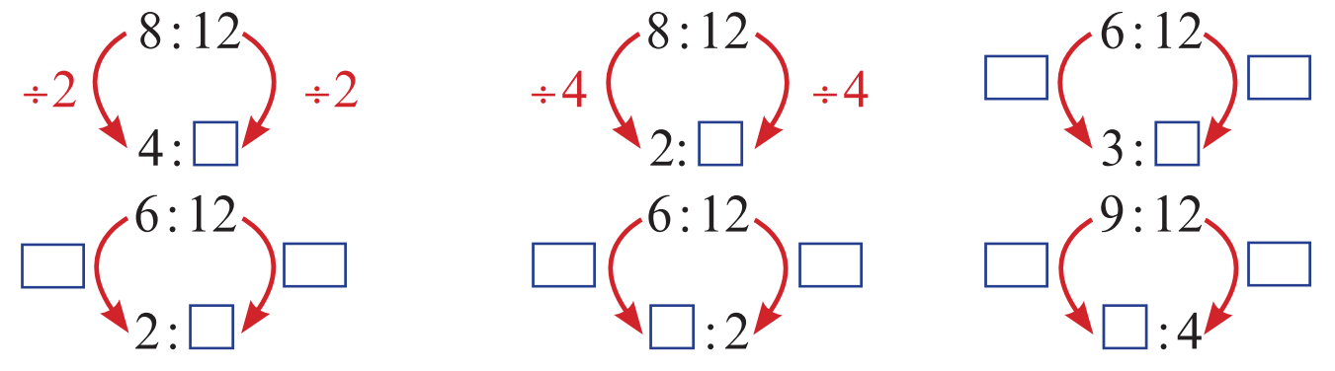  6
4 | 1 | 3

- Darius thinks the ratio 2:3 is the same as the ratio 1:2, as the numbers have both been increased by 1.
  - Explain why Darius is wrong.
To find equivalent ratios, we must multiply or divide, not add or subtract
  - Find a ratio that is the same as 2:3
$$4:6$$
- Complete each equivalent ratio.
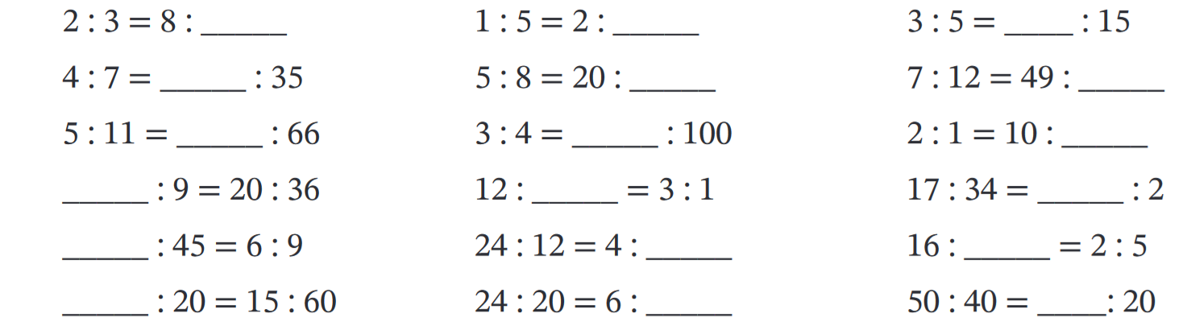  12 | 10 | 9
30 | 75 | 5
5 | 4 | 1
5 | 5 | 25

Simplifying Ratios

- Review
- Identify highest common factor
- 12 and 16 | - 18 and 27 | - 250 and 100
- 16 and 36 | - 48 and 36 | - 75 and 25

- Simplify fractions
- $\frac{6}{16}$ | - $\frac{12}{15}$ | - $\frac{10}{2}$
- $\frac{9}{24}$ | - $\frac{70}{14}$ | - $\frac{32}{10}$

- Convert units
- 60 cents to dollars | - 300 mm to cm | - 12 km to m
- 0.5 m to cm | - 1.5 hours to minutes | - 1.7 kg to g

- Simplifying Ratios
A simplified ratio has no common factors shared between the numbers in the ratio.
To simplify a ratio:
1. Identify the highest common factor (HCF) of all the parts.
2. Divide each part by the HCF.
- You can simplify ratios using a calculator by treating it as a fraction.
This won’t work when a ratio has three or more numbers.

- Example Simplify ratios
$6 : 16$  $÷2 ÷2$  $3 : 8$ | $$3 : 12 : 15$$  $$÷3 ÷3 ÷3$$  $$1 : 4 : 5$$

- Guided Practice
Simplify these ratios
- $10 :2$  5:1 | - $20 :45$  4:9 | - $16 :40$  2:5
- $50 :75$  2:3 | - $10 :35 :15$  2:7:3 | - $32 :12 :8$  8:3:2

- Key Ideas
- To simplify ratios, ……………… all parts of the ratio by the …………………… ………………… ……………………

- Simplifying Ratios with Different Units
Ratios should compare the same units.
To simplify a ratio, first convert all units to the same.
Convert to the smaller unit to avoid decimals.

- Example Simplify ratios with different units
$18 mm : 6 cm$  $18 mm : 60 mm$  $÷6 ÷6$  $3 : 10$ | $\$2 : 50 c$  $200 c : 50 c$  $÷50 ÷50$  $4 : 1$

- Guided Practice
Simplify these ratios
- 24 mm : 3 cm  4 : 5 | - 2.5 km : 500 m  5 : 1
- $3.50 : 30 c  35 : 3 | - 45 min : 2 hours  3 : 8

- Key Ideas
- When simplifying ratios, the ……………… of all parts of the ratio must be the same.

Foundation
- Write the ratios in simplest form, using the visual models.
Show the operation you do to both parts of the ratio.
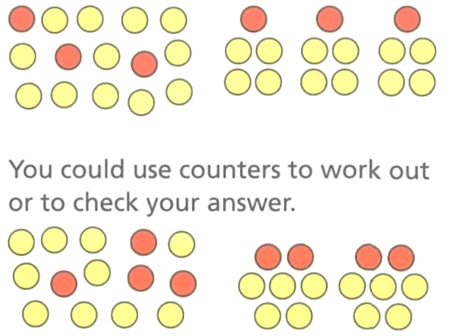    $3:12$    1:4 | $4:10$  2:5

- Simplify these ratios.
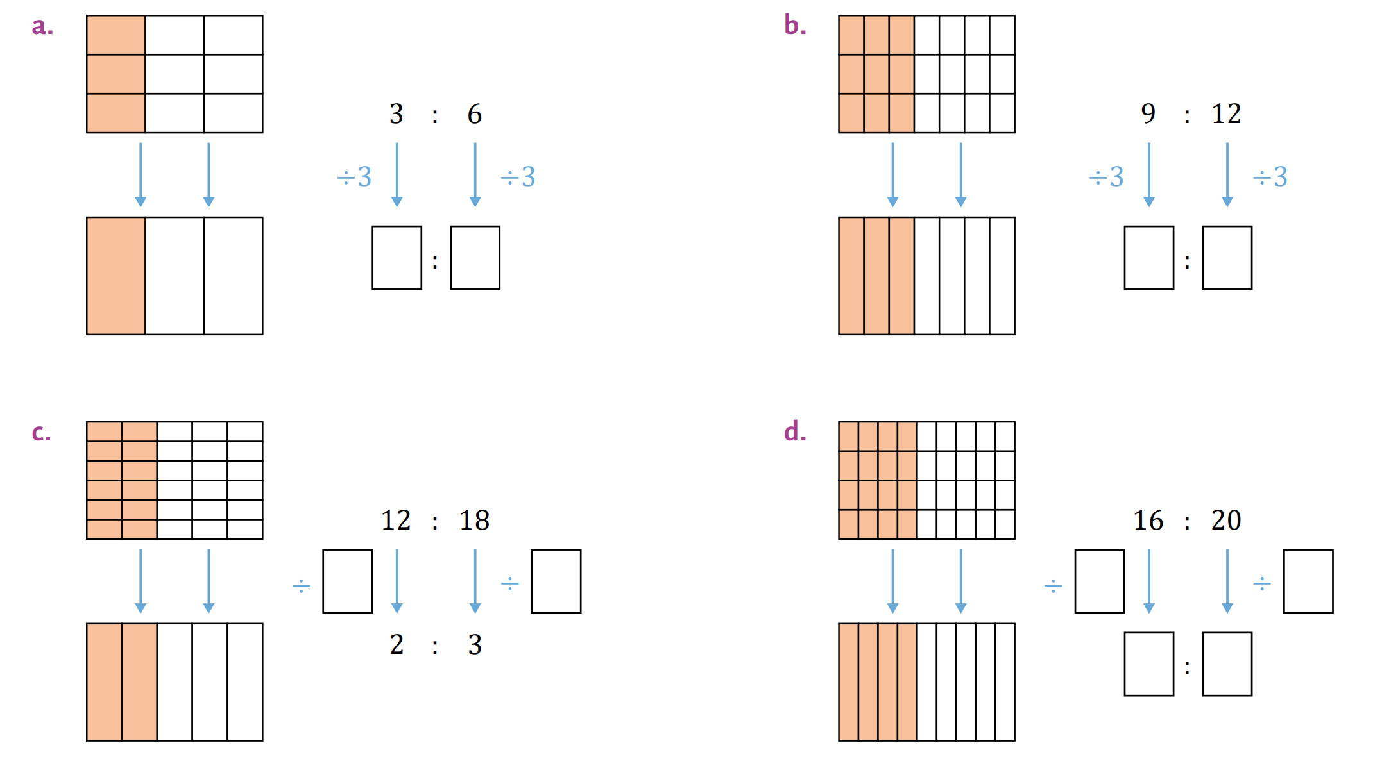  1:2 | $$÷6$$ | $$÷4, 4:5$$

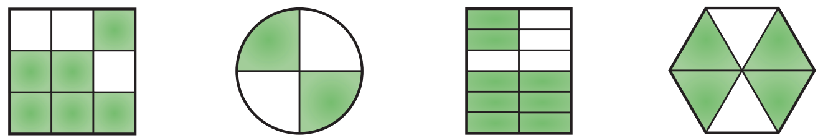
- Write the ratios of the shaded to unshaded parts for these diagrams, then simplify the ratio to simplest form.
2:1 | 1:1 | 2:1 | 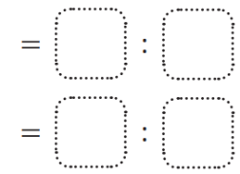  2:1

- Simplify these ratios.
- 10 : 50  1:5 | - 8 : 10  4:5 | - 21 : 28  3:4 | - 18 : 14  9:7
- 45 : 35  9:7 | - 51 : 17  3:1 | - 145 : 45  29:9 | - 200 : 125  8:5

Development

  - Simplify 120 : 300
2:5
  - Simplify $\frac{120}{300}$
$$\frac{2}{5}$$
  - What is the same about your methods for a and b?
Divide both numbers by the HCF.
- Kim was absent from school on 8 days in Term one. There were 44 school days in term one. Write the following ratios in simplest form.
- days absent to total days  $2:11$ | - days present to total  $$9:11$$ | - absent days to present  $$2:9$$
  - complete the sentence: for every 9 days she is present, Kim is absent …… days.
2

- For every $1 Ali has, Cathy has 50 cents.
  - Explain why the ratio of Ali’s money to Cathy’s is not 1:50.

the units are different.
  - What would the ratio of Ali’s money to Cathy’s be, in simplest form?
2:1
- Simplify the ratios by first changing the quantities to the same units first.
- 12 mm to 3 cm  12 mm : 30 mm  ……… : ………  2:5 | - 120 m to 1 km  3:25 |  | - 3 kg to 450 g  20:3 |  | - 400 mL to 1 L  2:5
- 3 hours to  15 minutes  12:1 |  | - 180 minutes to  2 hours  3:2 |  | - 50 cents to $5  1:10

Mastery
- Fred incorrectly simplified 12 cm to 3 mm as the ratio 4:1.
Explain his mistake and what is the correct answer?

The units are different. The correct answer is 40:1.
- Ratios can compare three quantities. Simplify the following by dividing each part by the HCF.
- 8 : 12 : 20  2:3:5 | - 15 : 20 : 30  3:4:6 | - 27 : 9 : 36  3:1:4
- 12 : 21 : 33  4:7:11 | - 12 : 24 : 36  1:2:3 | - 270 : 420 : 60  9:14:2

- Ratios always have the same units. Convert units to be the same then simplify.
- 80c : $8  1:10 | - 90c : $4.50  1:5 | - 80 cm : 1.2 m  2:3
- 0.7 kg : 800 g  7:8 | - 2.5 kg : 400 g  25:4 | - 30 min : 2 hours  1:4
- 45 min : 3 hours  1:4 | - 4 hours : 50 min  24:5 | - 40 cm : 2 m : 50 cm  4:20:5

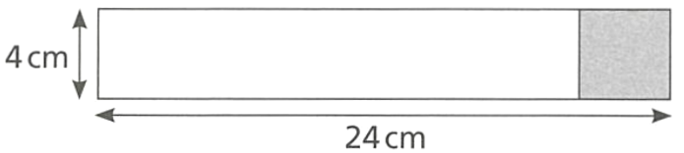
- The shaded part of the rectangle is a square.
What is the ratio of the white area to the shaded area, in simplest form?

5:1

Simplifying Ratios with Fractions and Decimals

- Review
- Rewrite fractions with the lowest common denominator
- $\frac{5}{4}$ and $\frac{1}{3}$ | - $\frac{4}{5}$ and $\frac{2}{3}$ | - $\frac{2}{3}$ and $\frac{5}{6}$

- Multiply both numbers by a power of 10 to get whole numbers.
- 0.7 and 9 | - 0.07 and 9 | - 0.07 and 0.025

- Ratios with Fractions and Decimals
A fully simplified ratio has no fractions and no decimals.
- If there are decimals:
- Multiply each part by a power of 10 to get whole numbers.
- Divide by the highest common factor.
- If there are fractions:
- Rewrite the fractions with their lowest common denominator.
- Multiply by the denominator.
- Simplify the result, if needed.

- Example Simplify ratios with fractions and decimals
$$3 :2.7$$  $$×10 ×10$$  $$30:27$$  $$÷3 ÷3$$  $$10:9$$ | We multiply both parts by 10 so that each part is a …………… number.
$$\frac{5}{4} :\frac{2}{3}$$  $$\frac{15}{12} :\frac{8}{12}$$  $$×12 ×12$$  $$15:8$$ | We first changed both the denominators to 12 because that is the …………… of 3 and 4.  By changing both denominators to 12, we were able to …………… to get rid of it.
- Guided Practice
Simplify these ratios
$$0.1 :1.05$$  $$2 :21$$ | $$2 :5.5$$  $$4 :11$$
$$\frac{4}{5} :\frac{2}{3}$$  $$6 :5$$ | $$\frac{2}{3} :\frac{5}{6}$$  $$4 :5$$
$$0.3 :4 :0.02$$  $$15 :200 :1$$ | $$\frac{3}{4} :\frac{1}{2} :\frac{2}{5}$$  $$15 :10 :8$$

- Key Ideas
- Simplified ratios have no fractions or ……………………

Foundation
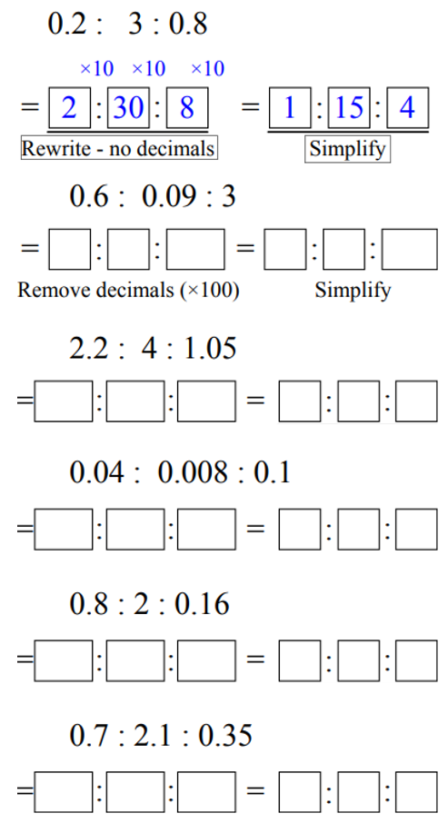
- Simplify these ratios involving decimals.
 | 20:3:100
44:80:21 | 10:2:25
10:25:2 | 2:6:1
- Simplify these ratios involving fractions.
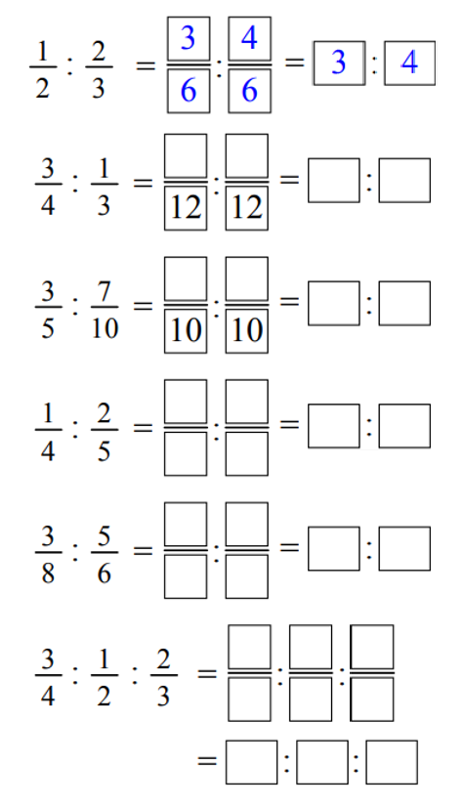  3:4 | 9:4
6:7 | 5:8
9:20 | 9:6:8
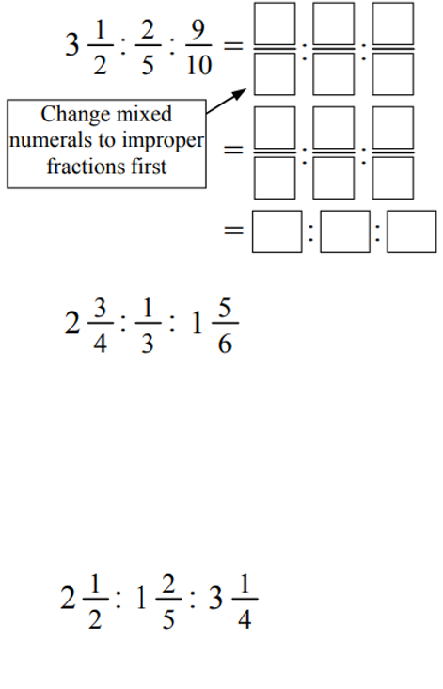  35:4:9 | 33:4:22

Development
- Simplify these ratios
- 18 : 30  3 : 5 | - 0.18 : 0.3  3 : 5 | - $\frac{2}{3} :\frac{5}{9}$  6 : 5
- 30 : 18  5 : 3 | - 18 cm : 0.3 m  3 : 5 | - $\frac{1}{2}$ : 0.75  2 : 3
- 18 : 30 : 42  3 : 5 : 7 | - $1.80 : 300 c  3 : 5 | - 1.2 kg : 450 g : 0.3 kg  8 : 3 : 2
- 1.8 : 3  3 : 5 | - $\frac{3}{4} :\frac{5}{8}$  6 : 5 | - 1.5 h : 45 min  2 : 1

- Simplify these ratios.
- $10 :16$  5:8 | - $32 :24$  4:3 | - $15 :10$  3:2 | - $0.8 :2.4$  1:3
- $16 :10$  8:5 | - $32 :48$  2:3 | - $150 :200$  3:4 | - $\frac{8}{10}:\frac{24}{10}$  1:3
- $8 :10$  4:5 | - $64 :96$  2:3 | - $3 :2$  3:2 | - $8x :24x$  1:3
- $4 :5$  4:5 | - $64 :96 :20$  16:24:5 | - $24 :8$  3:1 | - $8 :24 :32$  1:3:4
- $4.5 :5$  9:10 | - $128 :96 :20$  32:24:5 | - $80 :240$  1:3 | - $0.5 :1.5 :2$  1:3:4
- Sometimes ratios are more useful simplified to the form $1:n$; we divide both parts by the value of the first part. Express these ratios in the form $1:n$. Leave numbers as decimals.
- 10 : 35  $÷10 ÷10$  1 : ……  1 : 3.5 | - 40 : 72  $÷40 ÷40$  1 : 1.8 | - 24 : 60  1 : 2.4 | - 80 : 72  $$1 :0.9$$
- 50 : 87  1 : 1.74 | - 90 : 40  1 : 0.$\dot{4}$ | - 60 : 48  1 : 0.8 | - 8 : 125  1 : 15.625
- 1 cm to 1 m  1 : 100 | - 1 mm to 1 m  1 : 1000 | - 20 mL to 1 L  1 : 50 | - 50 mg to 15 g  1 : 300

- Simplify these ratios.
- 25 : 35  5 : 7 | - 100 : 28 : 4  25 : 7 : 1 | - 1.6 : 1.9  16 : 19 | - 0.93 : 0.6  31 : 20
- $\frac{3}{2}$ : $2$ $\frac{1}{2}$  3 : 5 | - 2.2 kg : 850 g  44 : 17 | - 6 min : 2.1 h  1 : 21 | - $\frac{1}{2}$ : $\frac{1}{3}$  3 : 2
- 25 cm : 1.1 m  5 : 22 | - $1.50 : 80 c  15 : 8 | - 600 mL : 1.5 L  2 : 5 | - $\frac{5}{8}$ : $\frac{2}{3}$  15 : 16

Mastery
- Simplify these ratios by converting all units to be the same first.
- 15 cm : 0.6 m : 30 mm  5 : 20 : 1 | - 2 min : 45 s : 1 min 25 s  24 : 9 : 17 | - 1.2 kg : 800 g : 0.4 kg  3 : 2 : 1
- 600 L : 4.2 kL : 0.9 kL  2 : 14 : 3 | - $3.60 : 45 c : $2.07  40 : 5 : 23 | - 3 weeks : 1 fortnight  3 : 2
- 6000 mg : 12 g : 0.06 kg  1 : 2 : 10 | - 10 cm² : 200 mm²  5 : 1 | - 600 m² : 1 ha  3 : 50

- Using the dimensions provided, find the ratio of the shaded area to the unshaded area for each of the following diagrams. (Hint: for the circles, leave your answer in terms of pi).
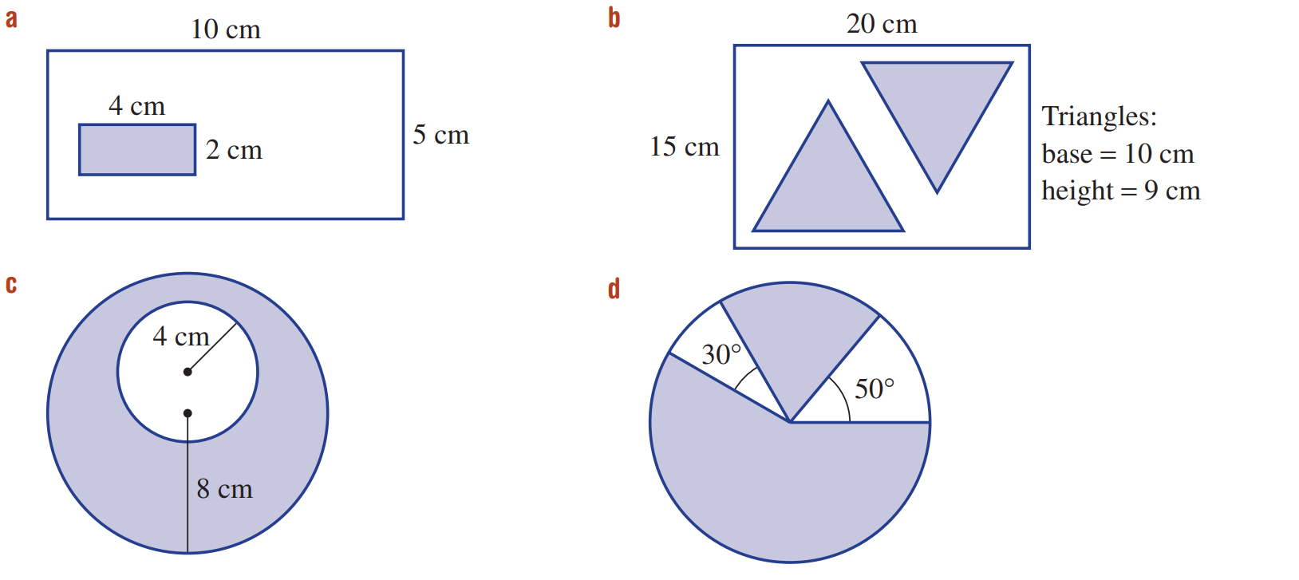  8 : 42 = 4 : 21 | 90 : 210 = 3 : 7
$48π :16π=$3 : 1 | $280 :80=$7 : 2

- In the diagram below:
The base of triangle A is half the length of the rectangle.
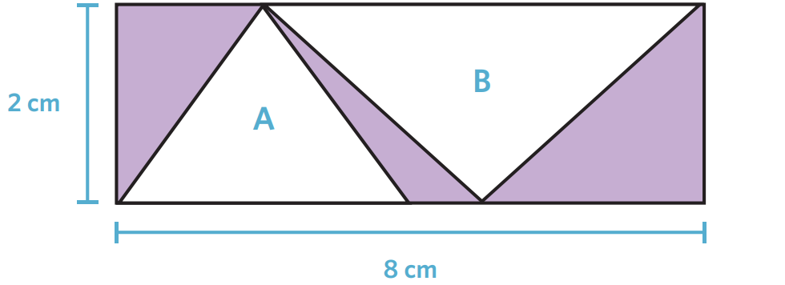
The base of triangle B is three quarters of the length of the rectangle.

Find the ratio of the unshaded area to the shaded area.

Triangle A: 4 cm²
Triangle B: 6 cm²
Unshaded to shaded = 5 : 3

Solving Problems using Equivalent Ratios

- Solving Problems with Ratio $1:n$
If a problem gives a ratio $1:n$, we can solve it using equivalent ratios.
- Set up a ratio table with the two quantities.
- Use equivalent ratios to find the unknown quantity.

- Example Solve ratio problems using equivalent ratios
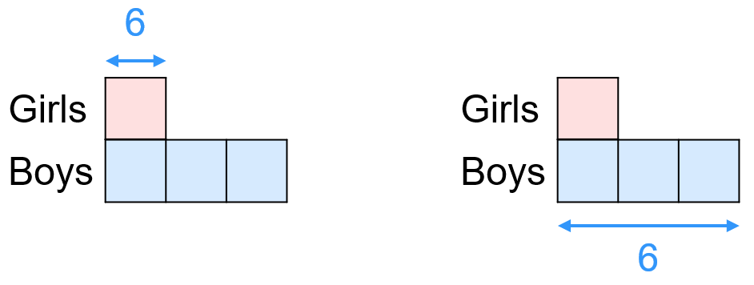
The ratio of girls to boys in a class is 1:3. There are 6 girls, how many boys are there?

1. Ratio table | 2. Find unknown  $$\underset{→}{×3}$$  $$×6$$  $$×6$$  There are 18 boys.
  Girls | $$:$$ | Boys
  1 | $$:$$ | 3
  6 | $$:$$
  Girls | $$:$$ | Boys
  1 | $$:$$ | 3
  6 | $$:$$ | 18

- Guided Practice
- The ratio of girls to boys in a class is 1:3. There are 6 boys, how many girls are there?  2 | - The ratio of adults to children in a nursery is 1 : 4. There are 20 adults,  how many children are there?  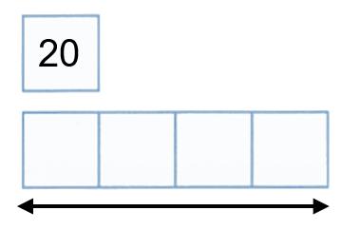  Adults:  Children:  80
  Girls | $$:$$ | Boys
  1 | $$:$$ | 3
   | $$:$$ | 6
  Adult | $$:$$ | Child
  1 | $$:$$ | 4
   | $$:$$
- The ratio of teachers to students on an excursion is 1 : 15. There are 60 students. How many teachers are needed?  4 | - The ratio of milk to cream in a recipe is 1 : 3. If I use 2.5 cups of milk, how many cups of cream do I need?  7.5

Foundation
- Orange drink is made by mixing cordial and water in the ratio 1:7.
- If you have 50 mL of cordial, how much water do you need?  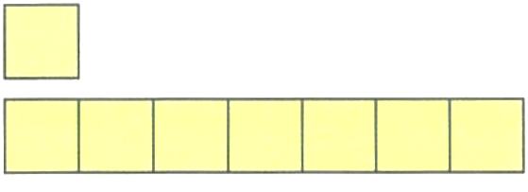  Cordial:  Water:  350 mL | - If you have 560 mL of water, how much cordial do you need?  Cordial:  Water:  80 mL
  Cordial | $$:$$ | Water
  1 | $$:$$ | 7
  50 | $$:$$
  Cordial | $$:$$ | Water
   | $$:$$
   | $$:$$

- A child-care centre requires an adult to child ratio of 1 : 4.
- Find the number of children that can be cared for by 2 adults.  8 | - Find the number of adults that are required to care for 12 children.  3
- Find the number of children that can be cared for by 10 adults.  40 | - Find the number of adults that are required to care for 52 children.  13

- A drink is made by mixing water and cordial in the ratio 5:1.
- How much water do you need for 60 mL of cordial?  300 mL | - How much cordial do you need for 200 mL of water?  40 mL | - What fraction of the drink is water?  $$\frac{5}{6}$$

Development

- Red : blue = $1:4$.  There are 3 red counters.  How many blue counters are there?  12 blue counters | - Red : blue = $1:4$.  There are 20 blue counters.  How many red counters are there?  5 red counters
- Red : blue = $1:4$.  There are 2.5 L of red paint.  How many litres of blue paint are there?  10 L of blue paint | - Red : blue = $1:4$.  There are 7.2 L of blue paint.  How many litres of red paint are there?  1.8 L of red paint
- Teachers : students = $1:15$.  There are 7 teachers.  How many students are there?  105 students | - Teachers : students = $1:15$.  There are 180 students.  How many teachers are required?  12 teachers
- Cordial : water = $1:7$.  There are 350 mL of water.  How much cordial is required?  50 mL of cordial | - Width : length = $1:4$.  A rectangle has width 8 cm.  Find its length.  32 cm
- Width : length = $1:4$.  A rectangle has length 30 cm.  Find its width.  7.5 cm | - Milk : cream = $1:3$.  A recipe uses 4.5 cups of milk.  Find the amount of cream.  13.5 cups of cream
- The ratio of the width to length of a rectangle is 1: 4.
- If the width is 15 cm,  how long is the rectangle?  60 cm | - If the length is 20 cm,  how wide is the rectangle?  5 cm
- If the width is 12 cm,  what is the perimeter?  120 cm | - What fraction of the perimeter is one width of the rectangle?  $$\frac{1}{10}$$

- Rice and water are to be combined in a ratio of 2 : 3.
- Find the amount of water to combine with 12 cups of rice.  18 cups | - Find the amount of rice to combine with 12 cups of water.  8 cups

- In a nut mixture the ratio of peanuts to walnuts to cashews is 2 : 3 : 1.
- If the number of peanuts is 20, find the number of walnuts and cashews.  30 walnuts 10 cashews | - If the number of walnuts is 6, find the number of peanuts and cashews.  4 peanuts 2 cashews | - If the number of cashews is 8,  find the number of peanuts and walnuts.  16 peanuts 24 walnuts

Finding Lengths in Scale Drawings

- Scale Drawings
A scale drawing is a smaller or larger drawing of a real-life object.
Examples include maps, house plans, and scientific diagrams.
We call the real-life object the original, and the drawing the image.
Scales for scale drawings are written in simplified ratio notation:

$$image :original \\ 1 : n$$

A scale of 1:500 means every 1 unit on the drawing is 500 units in real life.
- Set up a ratio table image : original
  - The first row should be the given scale.
  - The second row should be the given length and the length you want to find.
- Find the unknown side by multiplying or dividing.

- Example Calculate original length using a ratio scale
A map has a scale of $1:500$.
What is the real-life distance that 28 mm on the map would represent?
1. Ratio table | 2. Find unknown  $$\underset{→}{×500}$$  The real-life distance is 14 000 mm, or 14 m.
  Image | $$:$$ | Original
  1 | $$:$$ | 500
  28 | $$:$$
  Image | $$:$$ | Original
  1 | $$:$$ | 500
  28 | $$:$$ | 14 000

- Guided Practice
- A map has a scale of $1:1000$.  What is the real-life distance that  37 mm on the map would represent?  37 000 mm or 37 m | - A city map has a scale of $1:10 000$.  If the distance between two landmarks on the map is 3 cm, what is the real-life distance between the landmarks?  30 000 cm or 300 m
  Image | $$:$$ | Original
   | $$:$$
   | $$:$$
  Image | $$:$$ | Original
   | $$:$$
   | $$:$$
- Example Calculate image length using a ratio scale
A map has a scale of $1:500$.
What length on the map would represent 85 m in real life?
1. Ratio table | 2. Find unknown  $$\overset{←}{÷500}$$  The map distance is 0.17 m, or 17 cm.
  Image | $$:$$ | Original
  1 | $$:$$ | 500
   | $$:$$ | 85
  Image | $$:$$ | Original
  1 | $$:$$ | 500
  0.17 | $$:$$ | 85

- Guided Practice
- A diagram has a scale of $1:200$.  What length on the diagram represents 450 metres in real life?  Answer in metres.  2.25 m | - A map has a scale of $1:10 000$.  What length on the map would represent 23 km in real life?  Answer in metres.  2.3 m
  Image | $$:$$ | Original
   | $$:$$
   | $$:$$
  Image | $$:$$ | Original
   | $$:$$
   | $$:$$
- A scientific poster shows a flea at a scale of 50 : 1. If the flea is 6 mm in length in real life, how large should it be on the poster, in centimetres?  30 cm | - A map has a scale of 1 : 500 000.  Two cities are 50 km apart in real life, how far apart are they on the map, in centimetres?  10 cm
  Image | $$:$$ | Original
   | $$:$$
   | $$:$$
  Image | $$:$$ | Original
   | $$:$$
   | $$:$$

Foundation
- A map has a scale of 1:50 000.
  - How many centimetres in real life does 1 cm on the map equal?
50 000 cm
  - Therefore, how many metres does 1 cm represent?
500 m
  - What is the scale factor, as a fraction?
$$\frac{1}{50000}$$

- A map scale is given as 1 cm = 100 m. Write this as a simplified ratio.

$$1:10 000$$

- A map has a scale of 1:100.  How many metres on the map does  300 m in real life equal?  3 m | - Your science teacher tells you to draw a scale drawing of a tree with scale 1:150.  If the tree is 45 m high, how high should it be in your drawing?  0.3 m or 30 cm
  Image | $$:$$ | Original
   | $$:$$
   | $$:$$
  Image | $$:$$ | Original
   | $$:$$
   | $$:$$
- A map scale is 1:200 000.  Chatswood to Redfern is 4 cm on the map. How far is it in real life?  8 km | - Blackbottle and Toowoola are 17 cm apart on a map with a scale of 1:50 000.  How many km apart are the towns in real life?  8.5 km
- The town of Gilgandra is 66 km north of Dubbo. On a map with a scale of  1 : 100 000, what is the scaled distance between the 2 towns?  66 cm | - Lord Howe Island is 2.8 km wide.  How long would its scaled width be on a map with a scale of 1 : 50 000?  5.6 cm

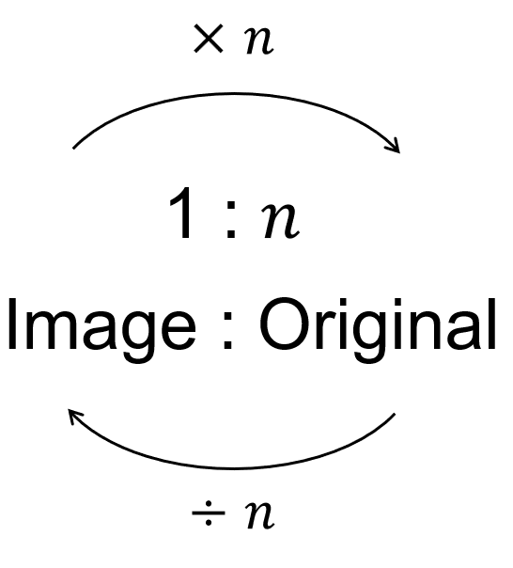
A shortcut you can use only if scale factor is given in the form $1:n$ or $n:1$

- Find the actual distance for the given scaled distances.
Give your answer in an appropriate unit.
- 1: 5 | i 44 m  $44 m×5=$ …………  220 m | ii 310 cm  1550 cm
- 1: 10 000 | i 2 cm  200 m | ii 4 mm  40 m
- 1: 20 000 | i 80 cm  16 km | ii 18.5 mm  370 m
- 1: 400 | i 16 mm  6.4 m | ii 0.03 m  12 m
- 1: 0.5 | i 12 cm  6 cm | ii 3.2 mm  1.6 mm
- 100: 1 | i 3 cm  0.03 cm | ii 11.5 km  115 m

- Find the scaled length for the given actual lengths.
- 1: 10 | i 40 m  $40 m÷10=$ …………  4 m | ii 310 cm  31 cm
- 1: 200 | i 200 m  1 m | ii 4 km  20 m
- 1: 500 | i 10 000 m  20 m | ii 75 cm  0.15 cm
- 1: 10 000 | i 1350 m  0.135 m | ii 45 km  4.5 m
- 1: 0.1 | i 23 m  230 m | ii 6.15 m  61.5 m
- 100: 1 | i 7.5 cm  750 cm | ii 8.2 m  820 m

Development

- Scale $1:500$. An image length is 3 cm.  Find the original length in metres.  15 m | - Scale $1:500$. An original length is 20 m.  Find the image length in centimetres.  4 cm
- Scale $1:25 000$. A map distance is 6 cm.  Find the original distance in kilometres.  1.5 km | - Scale $1:25 000$. Two places are 3 km apart.  Find their map distance in centimetres.  12 cm
- Scale $50:1$. An object is 8 mm long.  Find the image length in centimetres.  40 cm | - Scale $50:1$. An image is 30 cm long.  Find the original length in millimetres.  6 mm
- Scale $1:200$. A drawing length is 45 mm.  Find the original length in metres.  9 m | - Scale $1:200$. An original length is 7.2 m.  Find the drawing length in centimetres.  3.6 cm
- A cell is 0.012 mm long and is drawn at $500:1$.
Find the drawing length in millimetres.

6 mm

- A map scale is a ratio of scaled distance : real-life distance.
A map of a park was drawn using the scale ratio of 1 : 500.
  - 1 mm on the map represents ………… mm in real life.
500
  - 1 cm on the map represents ………… cm in real life.
500
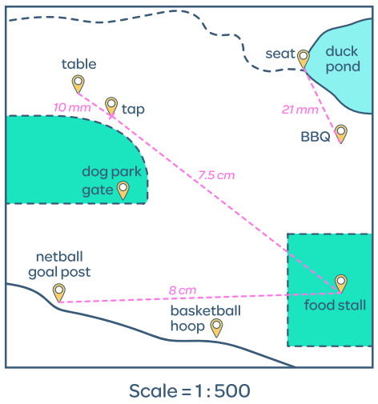
  - Calculate the real-life distance between the table and the tap:
Scaled | : | Real Life
1 | : | 500
10 | :

5000 cm
  - Convert your answer to metres: …………… m
50 m
  - Calculate the distance between the seat and
the BBQ in metres.

10.5 m
  - Calculate the real-life distance between the netball goal post and the food stall in metres.

40 m
  - In real life, the distance between the dog park and the food stall is 35 000 mm.
How far would it be on the map?

7 cm
- A model city has a scale ratio of 1 : 1000.
- Find the real-life height of a skyscraper that has a scaled height of 8 cm.  80 m | - Find the scaled length of a train platform that is 45 m long in real life.  4.5 cm
  Scaled | : | Real Life
   | :
   | :
  Scaled | : | Real Life
   | :
   | :
- A scientist draws a bacteria using the scale 100:1.
If the drawing is 7 cm long, how long is the bacteria in real life?
Scaled | : | Real Life
100 | : | 1
 | :
0.07 cm
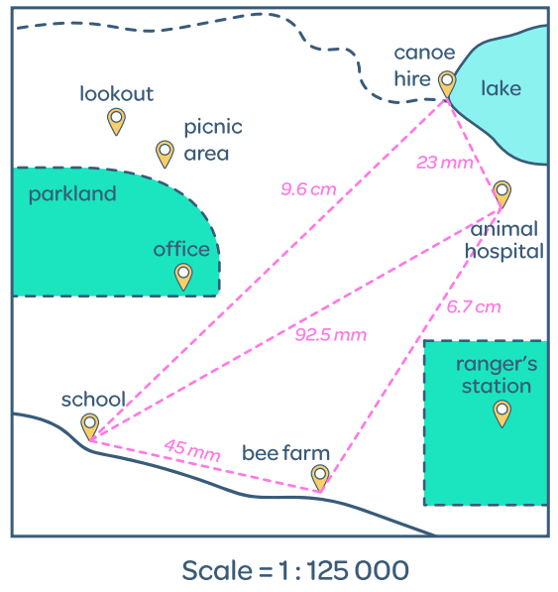
- A map is drawn with a scale of 1:125 000.
  - 1 mm on the map represents:
……………… mm in real life.
125 000
……………… cm in real life.
12 500
……………… m in real life.
125
……………… km in real life.
0.125
  - A teacher is planning a class excursion from the school to the bee farm.
What is the real-life distance between the two locations?

5.625 km
  - Between the office and the ranger station the real-life distance is 7 km.
How far apart would they be on the map?

56 mm

Mastery
- A map maker wants to make a map of an area that is 8 km by 8 km.
She decides to use a scale of 1:100. Explain why this map scale is not appropriate.

A 1:100 scale would make the 8 km × 8 km map 80 meters × 80 meters, which is impractically large for any practical use
- A scientist shows a photomicrograph image of a 10 cm long cell.
He says the cell is magnified by a scale of 1:100 000 through his microscope.
Explain what is wrong with the scientist’s ratio.

The scientist's ratio is backwards - a magnification should be written as 100,000:1, not 1:100,000, since the image is larger than the actual cell.
- An engineer designs a mobile phone SIM card using a diagram with a scale of 100:1.
If the scaled drawing is 80 cm long, what is its actual length in millimetres?

8 mm
- Your science teacher asks you to draw a scale diagram of a bacteria cell with a scale of 500:1
If the microscope says the bacteria is 0.01 mm in length, how long should the bacteria in your diagram be?

5 mm

- 2012 HSC Standard 2 Band 5
A map has a scale of 1 : 500 000.
Two mountain peaks are 2 cm apart on the map.
What is the actual distance between the two mountain peaks, in kilometres?

10 km
Two cities are 75 km apart. How far apart are the two cities on the map, in centimetres?

15 cm
- 2021 HSC Standard 2 Band 5
A rectangular sportsground has been drawn to scale on a 1-cm grid as shown.
The scale used is 1: 3000
Kerry took 12 minutes to walk around the perimeter of this sportsground.
What was Kerry's average speed in kilometres per hour?
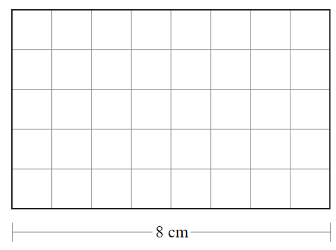

3.9 km/h

Ratio Problems using the Unitary Method

- Solving Problems with Ratio $m:n$
If a problem gives a ratio $m:n$, one part’s value, and asks for the value of the other,
we can solve it using the unitary method.
- Identify the number of parts the given quantity represents.
- Divide to find 1 part’s value.
- Multiply to find the required number of parts.

- Example Solve ratio problems using the unitary method
Purple paint is made by mixing red and blue paint in the ratio 2:3.
How much red paint do you need to mix with 12 L of blue paint?
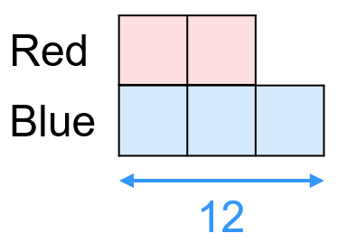 | $$3 parts=12 L$$  $$÷3 ÷3$$  $1 part=4 L$  $$×2 ×2$$  $$2 parts=8 L$$  You will need 8 L of red paint.

- Guided Practice
- The ratio of girls to boys in a class is 3:5. If there are 9 girls, how many boys are there?  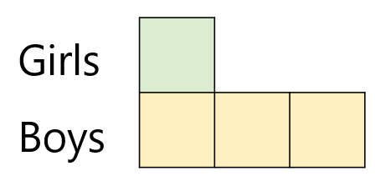  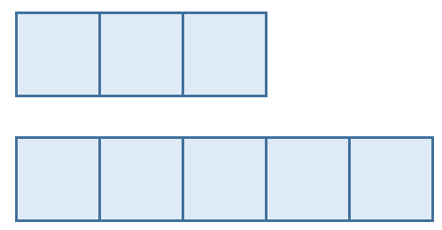  15 boys | - Purple paint is made by mixing red and blue paint in the ratio 5:2.  If you use 10 L of blue paint, how many litres of red paint are needed?  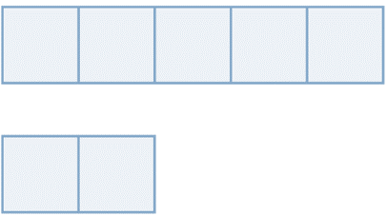  Red  Blue  25 L red paint
  …… parts | = | 9
  1 part | = | …………
  …… parts | = | …………
  …… parts | = | 10
  1 part | = | …………
  …… parts | = | …………

Foundation

- The ratio of apples to bananas is 2:3.  If there are 18 apples, how many bananas are there?  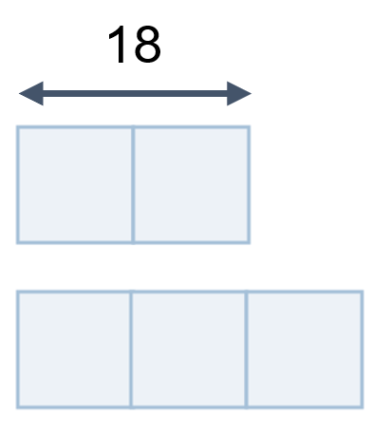  Apples  Bananas  27 | - The ratio of boys to girls in a class is 3:5.  If there are 20 girls, how many boys are in the class?  Boys  Girls  12
  …… parts | = | 18
  1 part | = | ……………
  …… parts | = | ……………
  …… parts | = | 20
  1 part | = | ……………
  …… parts | = | ……………

- A drink is made by mixing water and cordial in the ratio 5:2.
- How much cordial  do you need for  200 mL of water?  80 mL | - How much water  do you need for  60 mL of cordial?  150 mL | - How much drink, in total, can you make with  120 mL of cordial?  420 mL
  …… parts | = | 200
  ………… | = | ………
  ………… | = | ………
  …… parts | = | 60
  ………… | = | ………
  ………… | = | ………
  …… parts | = | 120
  ………… | = | ………
  ………… | = | ………

- To make pink paint, white and red paint need to be mixed in the ratio 3:4.
How much white paint is needed to mix with 10 L of red paint?

7.5 L
- In a recipe, for every 3 cups of milk, 4 cups of water are used.
Chloe has 6 cups of water. How much milk will she need?

4.5 cups

- Apples : bananas = $3:5$.  There are 12 apples.  Find the number of bananas.  20 bananas | - Apples : bananas = $3:5$.  There are 35 bananas.  Find the number of apples.  21 apples
- Apples : bananas = $3:5$.  There are 12 apples.  Find the total number of fruits.  32 fruits | - Apples : bananas = $3:5$.  There are 35 bananas.  Find how many more bananas than apples there are.  14 more bananas
- Red : blue = $5:2$.  There are 7.5 L of blue paint.  Find the red paint required.  18.75 L of red paint | - Boys : girls = $4:7$.  There are 18 boys.  Find the number of girls.  31.5 girls
- Boys : girls = $4:7$.  There are 31.5 girls.  Find the number of boys.  18 boys | - Pine : oak = $6:7$.  There are 21 m of oak.  Find the pine required.  18 m of pine
- Two connected road sections are in the ratio $3:4$.  The first is 24 km.  Find the combined distance.  56 km | - Milk : water = $3:4$.  There are 6 cups of water.  Find the milk required.  4.5 cups of milk

Development
- At a cake sale, you sold cupcakes and cookies in the ratio 5:4.
- If you sold 15 cupcakes, work out the number of cookies sold.  12 | - If you sold 15 more cupcakes than cookies, work out the number of cookies sold.  60

- In a rectangle, the ratio of the width to the length is 5 : 12. The length is 48 cm.
  - Find the width of the rectangle.
  - Find the perimeter of the rectangle.

width: 20 cm, perimeter: 136 cm
- Terry, Ash and Felicity share a prize in the ratio 11 : 8 : 6. Ash received $720.
  - How much did Terry receive?
  - How much more money did Ash receive compared to Felicity?
  - How much was the total prize money?

Terry: $990, Ash received $180 more than Felicity, total: $2250
- The ratio of the distance between Marble Cliff and Stone Lake to the distance between Stone Lake and Glacier Forest is 3 : 4
The distance between Marble Cliff and Stone Lake is 21 km.
Find the distance between Marble Cliff and Glacier Forest.
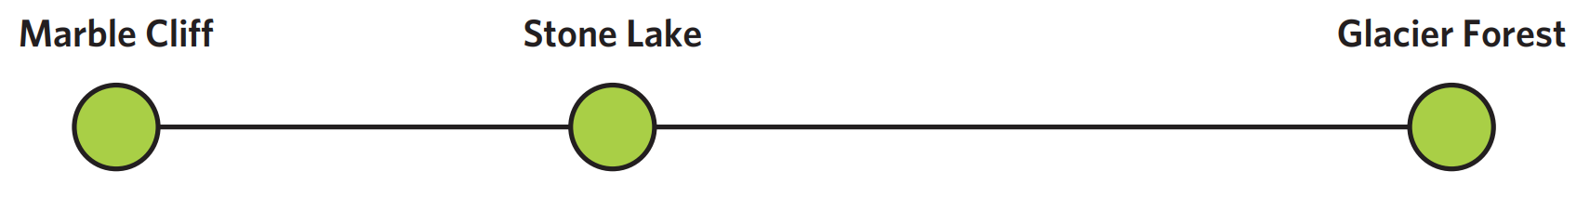

49 km
- Paula is making a wooden box. She knows that for every $\frac{3}{5}$ m of pine she needs 70 cm of oak.
  - She states that the ratio of pine to oak is $\frac{3}{5}$ $:70$. Explain why she is incorrect.

the units are different.
  - Write the correct simplified ratio of pine to oak.

6:7
  - How many metres of pine would she need if she wants to use 14 m of oak?

12 m
- $\frac{3}{7}$ of a company workforce are male.
  - What is the ratio of female to male in the workforce?

4:3
  - 160 females work for the company. How many people work for the company altogether?

280

- In an office, the ratio of men to women is 3 : 4.
12 men, which is 20% of the number of men in the office, wear glasses.
  - How many men work in the office?

60 men
  - How many women work in the office?

80 women
  - 15% of the women wear glasses.
Work out the total percentage of employees who wear glasses.

17.14%

Solving Ratio Problems using Equivalent Fractions

Foundation
- When two ratios are equivalent, we can express this using fractions.
E.g., $1:2=4:8→$ $\frac{1}{2}=\frac{4}{8}$
- Represent $x:y=5:1$ using fractions.  $$\frac{x}{y}=\frac{5}{1}$$ | - Represent $x:y=3:4$ using fractions.  $$\frac{x}{y}=\frac{3}{4}$$ | - Represent $2:3=x:y$ using fractions.  $$\frac{2}{3}=\frac{x}{y}$$

- Find the value of $x$ in these equivalent ratios.
- $\frac{x}{15}$ $=$ $\frac{6}{5}$  18 | - $\frac{x}{4}$ $=$ $\frac{9}{12}$  3 | - $\frac{x}{7}$ $=$ $\frac{1}{4}$  1.75
- $x:6=18:90$  1.2 | - $15:48=x:16$  5 | - $12:15=x:75$  60

- When working with equivalent ratios, we should set up the fraction so that $x$ is in the numerator.
- 20 : 16 $=$ 2 : $x$  $$\frac{x}{2}=\frac{16}{20}$$  1.6 | - $6:27=42:x$  189 | - $12:15=8:x$  10
- $16:14=4:x$  3.5 | - $8:x=25:22$  7.04 | - $x:9=4:x$  6

Development
- Solve these ratio problems using the algebraic fractions method.
- Set up ratio table.
- Use the rows in the table to set up an equation, always have $x$ in the numerator.
- The ratio of tin to lead in a type of metal is 8 : 5. How much tin is needed for 35g of lead?  $$\frac{x}{35}=\frac{8}{5}$$  56 g | - The ratio of tin to lead in a type of metal is 8 : 5. How much lead is needed for 70g of tin?  $$\frac{x}{70}=\frac{}{}$$  43.75 g
  Tin | $$:$$ | Lead
  8 | $$:$$ | 5
  $$x$$ | $$:$$ | 35
  Tin | $$:$$ | Lead
   | $$:$$
   | $$:$$
- The length and width of a rectangle are in the ratio of 9 : 4. Find the length of the rectangle when the width is 5.2 cm.  11.7 cm | - The length and width of a rectangle are in the ratio of 9 : 4. Find the width of the rectangle when the length is 128.7 cm.  57.2 cm
  $$:$$
  $$:$$
  $$:$$
  $$:$$
  $$:$$
  $$:$$
- The ratio of a boy’s height to his father’s is 3 : 5. If the boy’s height is 1.23 m, how tall is his father?  2.05 m | - The ratio of Carla’s weight to Tracey’s weight is 7 : 9. If Tracey weighs 82.8 kg, how much does Carla weigh?  64.4 kg

Dividing in a Ratio

- Dividing a Total in a Given Ratio
In a part:part ratio, add the parts to find the total.
Dividing in a ratio means finding part values from a total.
Use the unitary method to solve these problems.

- Example Divide a quantity in a given ratio and calculate the value of a part
Mr Ding and Mrs Balkizas divide $40 in the ratio 3:5, how much does each person get?
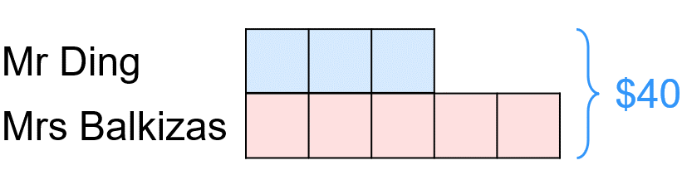 | $$8 parts=\$40$$  $$÷8 ÷8$$  $1 part=\$5$  $$×3 ×3$$  $$3 parts=\$15$$  $$5 parts=\$25$$  Mr Ding gets $15 and Mrs Balkizas $25.

- Guided Practice
- 54 sweets are shared in two piles in the ratio 2:7. How much is each pile?  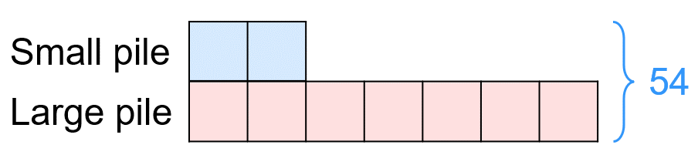  12 small pile : 42 large pile | - The ratio of boys to girls is 2:5. If there are 546 students, how many boys are there and how many girls are there?  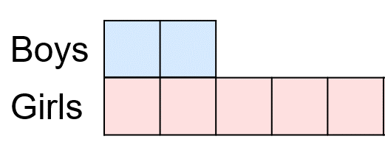  156 boys : 390 girls
  …… parts | = | 54
  1 part | = | …………
  …… parts | = | …………
  …… parts | = | …………
  …… parts | = | 546
  1 part | = | …………
  …… parts | = | …………
  …… parts | = | …………

- Example Divide a quantity in a given ratio and calculate the difference
Sienna and Ava share $63 in the ratio 2 : 5. How much more does Ava get than Sienna?
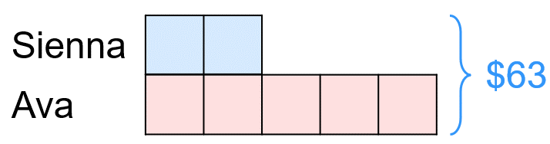 | $$7 parts=\$63$$  $$÷7 ÷7$$  $1 part=\$9$  $$×3 ×3$$  $$3 parts=\$27$$  The difference is $27

- Guided Practice
- A 60 cm piece of timber needs to be cut in the ratio 5 : 1.  What is the difference between the lengths of the two pieces?  40 cm difference | - A cordial drink needs 5 parts water  to 2 parts syrup.  How much more water is needed than syrup if making a drink that is 560 mL total?  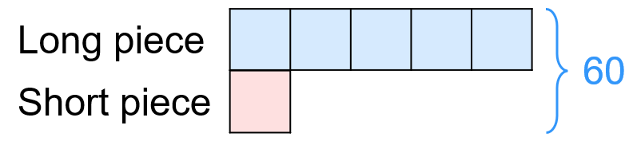  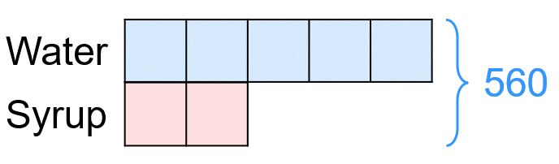  240 mL difference
  …… parts | = | …………
  1 part | = | …………
  …… parts | = | …………
  …… parts | = | …………
  1 part | = | …………
  …… parts | = | …………

Foundation
- Determine the total number of parts in each ratio.
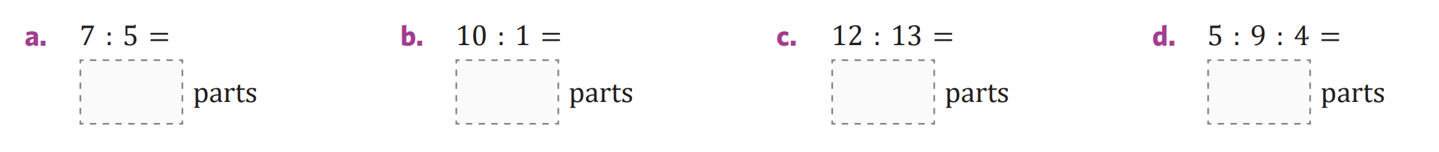  12 | 11 | 25 | 18

- Beth and Sven divide 40 sweets in the ratio 2:3.  How many sweets does Beth receive?  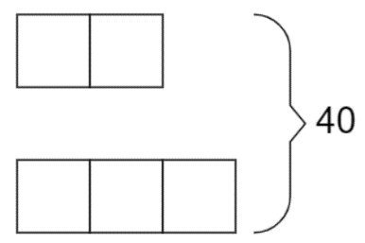  Beth:  Sven:  16 | - A 54 m long piece of timber is cut in the ratio 4:5.  Find the length of the shorter piece.  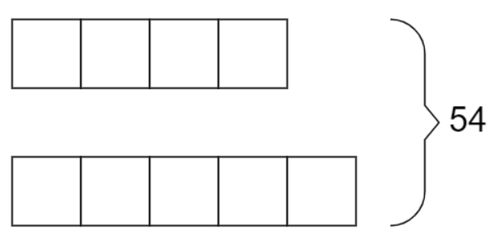  Shorter piece:  Longer piece:  24 m
  …… parts | = | 40
  1 part | =
  …… parts | =
  …… parts | =
  1 part | =
  …… parts | =
- James and Jemma scored goals in their netball game in the ratio 5:2.  If they scored 56 goals total, how many more goals did James score compared to Jemma?  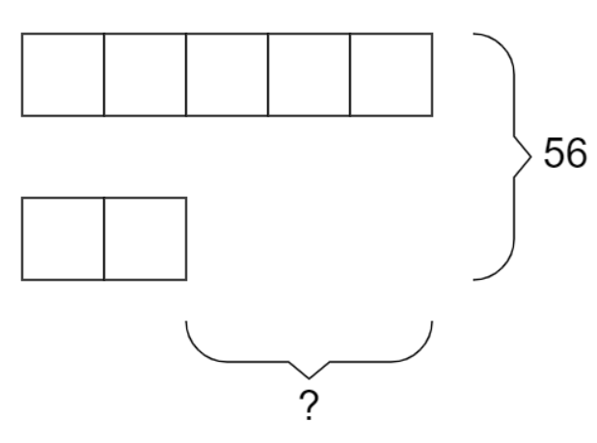  James:  Jemma:  24 | - Ben buys melons and bananas in the ratio 7:3.  If he buys 30 pieces of fruit in total,  how many more melons did he buy?  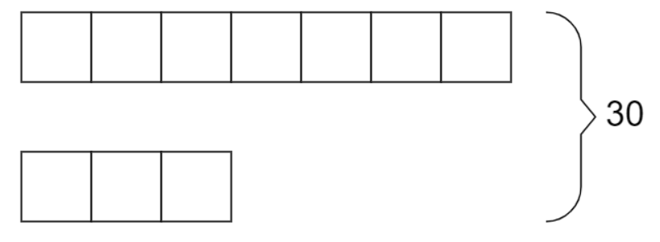  Melons:  Bananas:  12
  …… parts | = | 56
  …………… | = | ……………
  …………… | = | ……………
  …… parts | = | ……………
  …………… | = | ……………
  …………… | = | ……………

- Pink paint is made by mixing red and white paint in the ratio 1:2.  How much of each colour is there if you need to make 51 L of paint?  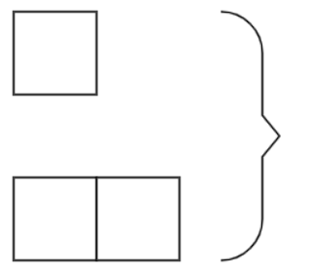  Red:  White:  Red: 17 L, White: 34 L | - David, Jimmy, and Rex are paid to do some gardening.  They are to be paid in the ratio 2:3:4.  If they are paid $72 in total, how much should each person receive?  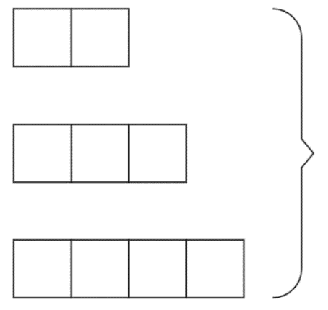  David:  Jimmy:  Rex:  David: $16, Jimmy: $24, Rex: $32
  …… parts | = | …………
  1 part | = | …………
  …… parts | = | …………
  …… parts | = | …………
  1 part | = | …………
  …… parts | = | …………
  …… parts | = | …………
  …… parts | = | …………
- Share 42 in the ratio $2:5$.  12 and 30 | - Share 42 in the ratio $5:2$.  30 and 12
- Two people share 63 in the ratio $2:5$.  Find the difference between their shares.  27 | - Two people share 63 in the ratio $2:5$.  Find the smaller share.  18
- Share 96 in the ratio $1:3$.  24 and 72 | - Share 120 in the ratio $2:3:5$.  24, 36 and 60
- The angles of a triangle are in the ratio $2:3:4$.  Find the angles.  40, 60 and 80 degrees | - A rectangle has perimeter 54 cm and width : length = $2:7$.  Find its dimensions.  width 6 cm, length 21 cm
- Two shares are in the ratio $3:7$. The smaller share is 24.  Find the total.  80 | - Two shares are in the ratio $3:7$. The difference is 20.  Find the total.  50

- Match the diagram to the situation.
  - Seb and Flo share some money. Seb gets $120.
iii
  - Seb and Flo share $120.
i
  - Seb and Flo share some money. Flo gets $120.
ii
  - Seb and Flo share some money. Flo gets $120 more than Seb.
iv
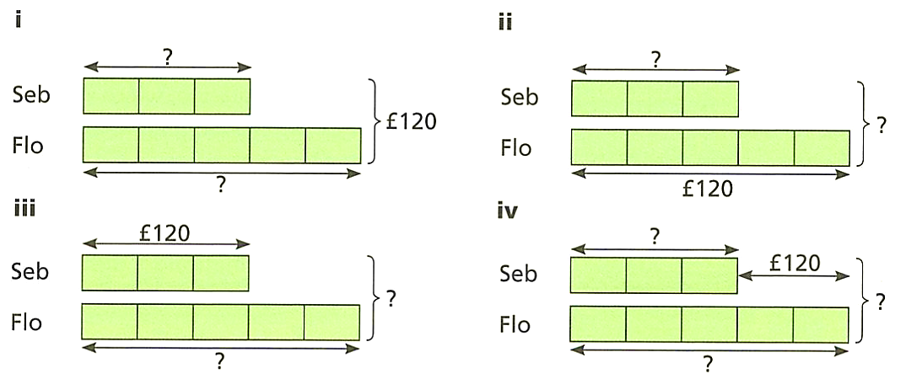
  - For each diagram, find the amount represented by the question mark.

45, 75 72, 84

200, 320 180, 480, 300

Development
- Solve these ratio problems without using a bar model.
- The required staff to student ratio for an excursion is 2:15. If 340 people attended the excursion, how many teachers were there?  40 teachers | - The ratio of commercials to actual show time for a particular TV channel is 2:3. How many minutes of actual show were there in 1 hour?  36 minutes
  …… parts | = | …………
  1 part | = | …………
  …… parts | = | …………
  …… parts | = | …………
  1 part | = | …………
  …… parts | = | …………
- Walter and William have a height ratio of 7:8. If their combined height is 285 cm, how tall is Walter?  133 cm | - Trudy and Bella make 80 biscuits. If Trudy makes 3 biscuits in the time that Bella makes 2 biscuits, how many biscuits does Trudy make?  48 biscuits
  …… parts | = | …………
  1 part | = | …………
  …… parts | = | …………
  …… parts | = | …………
  1 part | = | …………
  …… parts | = | …………
- Fertiliser is made up of three nutrients nitrogen, potassium and phosphorus in the ratio 4:5:3. How much of each nutrient is present in a 1.5 kg bag?

N: 500g, K: 625g, P: 375g
- Three friends, Cam, Holly and Seb, share a prize of $750 in the ratio 3:4:8.
How much more money does Seb receive than Cam?

$250
- All the angles in a triangle must add up to $180°$. The angles of a triangle are in the ratio 2 : 5 : 1. Calculate the sizes of the angles.

45°, 112.5°, 22.5°
- The angles in a triangle are in the ratio 1:2:3. Show that this must be a right-angled triangle.

The angles are 30°, 60°, 90°, so it is a right-angled triangle.
- The perimeter of a rectangle is 50 cm. The dimensions of the rectangle are in the ratio 4:1. Work out the area of the rectangle.

100 cm²
- ABC is a straight line 20 cm long.
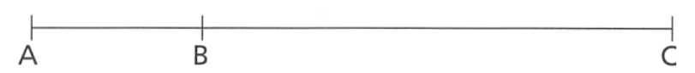

BC is three times as long as AB. Work out the length of AB.

5 cm
- HSC Standard 2 Sample Question Band 5
A farmer sells 216 sheep at a livestock auction.
Three buyers purchased all the sheep in the ratio 7:3:2.
How many sheep did the buyer of the highest number of sheep purchase?

126 sheep

Mastery
- Olivia says that to share an amount in the ratio 5 : 3,
you can simply multiply the total by $\frac{5}{8}$ and $\frac{3}{8}$ instead of using the unitary method.
  - Show that she is correct by using both methods to share $120
Unitary method | Fraction method  $$\frac{5}{8}×\$120=$$  $$\frac{3}{8}×\$120=$$  75 and 45
  …… parts | = | …………
  1 part | = | …………
  …… parts | = | …………
  …… parts | = | …………
  - Use Olivia’s method to share $6919 in the ratio 50:137.

1850 : 5069
- Amy and Ben have been given $60 to share between them.
How much will they each receive if they divide it in the ratio given? Use the fraction method.
- 4 : 1  $$Amy: \frac{4}{5}×\$60=$$  $$Ben: \frac{1}{5}×\$60=$$  $48 : $12 | - 1 : 2  $20 : $40 | - 3 : 1  $45 : $15
- 3 : 2  $36 : $24 | - 1 : 5  $10 : $50 | - 7 : 3  $42 : $18
- 1 : 9  $6 : $54 | - 2: 5 : 8  $8 : $20 : $32 | - 1: 4 : 3  $7.50 : $30 : $22.50

Mixed Applications

Foundation
- Solve these ratio questions.
  - Kate and Jack share 24 sweets in the ratio 1 : 3
How many sweets does Kate get?
6
  - Kate and Jack share 24 sweets in the ratio 3 : 1
How many sweets does Kate get?
18
  - Kate and Jack share 24 sweets in the ratio 6 : 2
How many sweets does Kate get?
18
  - Kate and Jack share 12 sweets in the ratio 3 : 1
How many sweets does Kate get?
9
  - Kate and Jack share some sweets in the ratio 3 : 1
Jack gets 12. How many does Kate get?
36
  - Kate and Jack share some sweets in the ratio 3 : 1
Kate gets 12. How many does Jack get?
4
  - Kate and Jack share some sweets in the ratio 3 : 1
Kate gets 12 more than Jack. How many does Jack get?
6
  - Kate and Jack share some sweets in the ratio 4 : 1
Kate gets 12 more than Jack. How many does Jack get?
4
  - Kate and Jack share some sweets in the ratio 4 : 1
Kate gets 15 more than Jack. How many does Jack get?
5
  - Kate and Jack share some sweets in the ratio 4 : 1
Jack gets 15. How many sweets do they have altogether?
75
  - Kate and Jack share some sweets in the ratio 4 : 1
What fraction of the sweets does Jack have?
$$\frac{1}{5}$$

- Marta and Faith share some sweets in the ratio 3:2.
- If there are 30 sweets altogether,  how many do they each get?  Marta: 18, Faith: 12 | - If Marta gets 30 sweets,  how many sweets were there altogether?  50
- If Faith gets 30 sweets,  how many sweets does Marta get?  45 | - If Marta gets 30 more sweets than Faith, how many sweets were there altogether?  150 sweets

- Ann, Beatrice, and Collie are sharing money in the ratio 2 : 3 : 7.
- What fraction of the money does Beatrice get?  $$\frac{1}{4}$$ | - If the total amount of money shared is $240, how much does Collie get?  $140
- If Beatrice gets $90, how much does Ann get?  $60 | - If Collie gets $20 more than Beatrice, how much does Ann get?  $10

- Chocolate is made of cocoa and sugar.
In milk chocolate, 20% of the mass is cocoa and 55% is sugar.
- What is the mass of cocoa in a chocolate bar weighing 250 g?  50 g | - A bar of milk chocolate contains 50 g of cocoa. How many grams of sugar does it have?  137.5 g
- What fraction of the bar is neither cocoa nor sugar?  $$\frac{1}{4}$$ | - What is the ratio of sugar to cocoa in a bar of chocolate, in simplest form?  11:4

Development
- The lengths of the sides of a triangle are in the ratio 3:4:5.
Find the length of each side of the triangle if:
- the perimeter is 192 cm  48 cm, 64 cm, 80 cm | - the shortest side is 9 cm  9 cm, 12 cm, 15 cm
- the longest side is 9 cm  5.4 cm, 7.2 cm, 9 cm | - the difference between the longest and shortest sides is 18 cm.  27 cm, 36 cm, 45 cm

- Complete the table.
 | Ratio  Jenny : Ben |  |  | Amount to Share | Jenny’s Amount | Ben’s Amount | Jenny gets more/less | Jenny’s amount as fraction of the whole.
 | 3 | : | 2 | $30 | $18 | $12 | $6 more | $$\frac{3}{5}$$
 | 3 | : | 2 | $40 | $24 | $16 | $8 more | $$\frac{3}{5}$$
 | 3 | : | 4 | $56 | $24 | $32 | $8 less | $$\frac{3}{7}$$
 | 1 | : | 4 | $40 | $8 | $32 | $24 less | $$\frac{1}{5}$$
 | 3 | : | 4 | $35 | $15 | $20 | $5 less | $$\frac{3}{7}$$
 | 3 | : | 8 | $33 | $9 | $24 | $15 less | $$\frac{3}{11}$$
 | 8 | : | 8 | $33 | $16.50 | $16.50 | Same | $$\frac{1}{2}$$
 | 8 | : | 4 | $24 | $16 | $8 | $8 more | $$\frac{2}{3}$$
 | 2 | : | 5 | $28 | $8 | $20 | $12 less | $$\frac{2}{7}$$
 | 9 | : | 7 | $28 | $15.75 | $12.25 | $3.50 more | $$\frac{9}{16}$$
- I eat $\frac{2}{9}$ of a chocolate bar. My friend eats $\frac{3}{7}$ of the bar.
- Who ate more chocolate?  The friend | - What fraction did we eat altogether?  $$\frac{41}{63}$$
- What percentage of the bar did I eat?  $22.\dot{2}$% | - Write the ratio of how much I ate to how much my friend ate in simplest form.  14:27

- Alfie and Becky share counters in the ratio 5:3. Becky receives 12. How many does Alfie receive?  20 | - Alfie and Becky share 32 counters in the ratio 5:3. How many does Alfie get?  20
- Alfie and Becky share counters in the ratio 5:3. Alfie gets 10 more than Becky. How many does each person have?  Alfie: 25, Becky: 15 | - Alfie and Becky share counters in the ratio 3:5. Becky receives 20 more than Alfie. How many are shared in total?  80
- A chocolate bar weighing 120g has these ingredients:
Cocoa: 28g
Sugar: 58g
Hazelnut Paste: 1.2g
The rest is milk powder.
- What fraction of the bar is sugar?  $$\frac{29}{60}$$ | - What is the ratio of hazelnut paste to cocoa?  3:70
- How many grams of milk powder is in the 120g bar?  32.8 g | - In a 30g bar, how much of each ingredient will there be?  Cocoa: 7g, Sugar: 14.5 g, Hazelnut: 0.3 g, Milk powder: 8.2 g

Mastery
- NAPLAN A+
It is known that one of the angles in a triangle is 120$°$.
Calculate the size of the other 2 angles if they are in the ratio $2:3$.

24° and 36°
- HSC Standard 2 Sample Question Band 4
A scalene triangle has angles in the ratio 9 : 2 : 4.
In degrees, what is the size of its largest angle?

108°
- HSC Standard 2 Sample Question Band 4
There are 48 people in a meeting room.
The ratio of females to males in the room is 13 to 11.
How many females need to leave the room so that the ratio of females to males in the room is 1 to 1?

4 females
- 2023 HSC Standard 2 Band 4
A bag contains 150 jellybeans. Some of them are red and the rest are blue.
The ratio of red to blue jellybeans is 2:3.
Sophie eats 10 of each colour.
What is the new ratio of red to blue jellybeans?

5 : 8
- 2022 HSC Standard 2 Band 5
A full container has 4.8 L of a mixture of cordial and water in the ratio 1:3.
After removing 1.2 L of the mixture, more water is added to refill the container.
What is the ratio of cordial to water in the final mixture?

3 : 13

Challenge Exercise
- Sam, Eddie and Maria invested $1500, $5000 and $9500 respectively when they started a new business. The total annual profit of $480 000 was shared in the same ratio as their investment. How much did each person receive?

$45 000, $150 000, $285 000
- For this question, study the worked example before and answer the questions.
Three quantities are in the ratio $p:q:r$
$p$ is 20% of $q$ and the ratio of $q:r=10:3$
Work out the ratio of $p:q:r$
Worked Solution | Explanation
$$p:q:r$$  $$p:10:3$$  $$p=0.2q \\ =0.2\left(10\right) \\ =2$$  $$∴p:q:r=2:10:3$$ | Explain what happened between these two lines.  They …………… q:r = 10:3 into the ratio p:q:r  Explain how we know $p=0.2q$  $p$ is ……% of q  Explain how we determined that $p=2$  Since we know q = …… from the previous ratio and p = ……q, we can substitute to find the value of $p$

- $m:n=3:8$. $r$ is 25% of $n$. Find the ratio $m:r$.

3 : 2
- Bobbie and Emily share some money in the ratio 2:5. Bobbie gives 20% of her share to Sven. Sven receives $24. Work out the original amount of money that was shared.

$420
- The algebraic fraction method is much more powerful than the unitary method when it comes to determining changes in the ratio. Read the worked example:
The ratio of boys to girls in a theatre is 3:2.
55 girls arrive and the ratio becomes 2:5.
Work out how many boys there are in this theatre.
Worked Solution | Explanation
Old ratio:  New Ratio:  $$\frac{3x}{2x+55}=\frac{2}{5} \\ 3x=\frac{2}{5}\left(2x+55\right) \\ 15x=2\left(2x+55\right) \\ 15x=4x+110 \\ 11x=110 \\ x=10$$  $∴$ There are 30 boys. | $3x$ represents the actual number of boys in the theatre, and $2x$ represents the actual number of girls.  The actual number represents multiples of parts in a ratio because we need to scale up both parts equally to get real values while maintaining the same ratio.  Explain why the new number of girls is  $2x+55$  ……… girls joined the original $2x$ girls.  Explain where this equation came from.  We set the new ratio of boys:girls equal to …… : ……  Annotate each step of the equation with the operation done to both sides.  Explain why the number of boys is $3x$, not $x$.  The original ratio showed …… parts for boys.
  Boys | : | Girls
  $3$ | : | $2$
  $3x$ | : | $2x$
  Boys | : | Girls
  $3x$ | : | $2x+55$
  $2$ | : | $5$

- A bowl contains apples and oranges in the ratio 1:3.
Ed adds 4 more apples to the bowl.
The ratio of apples to oranges is now 1:2. Work out the number of oranges in the bowl.

24 oranges

- The ratio of blue counters to orange counters in a bag is 1:4.
Five more blue counters are added to the bag.
The ratio of blue counters to orange counters is now 1:3.
Work out the total number of counters in the bag at the start.

75 counters
- Tim and Luke have money in the ratio 5:2.
Tim gives $10 to Luke and the ratio becomes 2:1.
Work out the original amount of money that Luke had.

$60
- The ratio of the number of marbles in box A to the number of marbles in box B is 7:3.
Jackson removes 3 marbles from box A and places them into box B. The ratio is now 5:3.
How many marbles were in each box originally?

28 in box A, 12 in box B
- The ratio of Rob's age to Ed's age is 4:5.
In 4 years, the ratio of their ages will be 5:6.
Work out how old Rob and Ed are now.

Rob 16 years, Ed 20 years
- Bottle A has 1 L of cordial drink with a cordial to water ratio of 3 :7.
Bottle B has 1 L of cordial drink with a cordial to water ratio of 1:4.
The drink from both bottles is combined to form a 2 L drink.
What is the new cordial to water ratio?

1 : 3
- Adam, Bertie, and Cameron are sharing $240. Work out how much each person receives.
- Bertie receives $60. The ratio of Adam’s to Cameron’s shares are 4:5.  A: $80, C: $100 | - Adam receives $\frac{1}{3}$ of the money. The ratio of Bertie to Cameron’s shares are 1 : 3.  B: $40, C: $120
- Cameron receives 20% more money than Adam. The ratio of Adam to Bertie is 5:1.  A: $100, B: $20, C: $120 | - The ratio of Adam to Bertie’s shares are 1: 3. The ratio of Bertie to Cameron’s shares are 1:2.  A: $24, B: $72, C: $144

- $w$ is 20% of $x$. $y$ is $\frac{2}{5}$ of $x$. Find the ratio $w:x:y$

1: 5 : 2
- The ratio of students to staff in a school trip is 25:3.
Note: each part is unrelated.
- What are the possible total number of staff and students on the trip?  Any multiple of 28. | - There are 12 members of staff. Some students then cancel. The ratio is now 15:2. How many students cancelled?  10
- At the last minute, 15 extra students and 15 extra staff join. The new ratio is 40:7. How many students and staff were there to begin with?  225 students, 27 staff | - The ratio of male to female students is 8:7 and the ratio of male to female staff is 4:5. What fraction of the total are male?  $$\frac{11}{21}$$

- Faith makes orange paint by mixing red and yellow paint.
She mixes 12 litres of red paint with 15 litres of yellow paint to get the right shade of orange.
Faith wants to make more of the same shade of orange paint.
She uses another 8 litres of yellow paint. How many more litres of red paint does she need?

6.4 L
- Jessie is making fuel for her leaf blower by mixing petrol with oil.
  - Her current container has 4.1 litres of fuel mixed in a ratio of 40:1 (petrol : oil).
How much petrol and how much oil are in this mixture?

4 L : 0.1 L
  - Jessie’s leaf blower manual states the correct mixing ratio should be 25:1 (petrol : oil).
If she wants to correct her mixture and already has 4 litres of petrol, how much oil should be in the mixture in total?

0.16 L
  - How much extra oil does Jessie need to add to her current mixture to achieve the correct ratio?

0.06 L or 60 mL
- Lily is making a drink by mixing water and cordial. She starts by making 5.4 L of drink using a ratio of 35:1. However, the instructions say she should use the ratio of 20:1. How much more cordial should she add to her current mixture so that the ratio is correct?

112.5 mL
- Find the value of $x$ in each case.
- $2x:3=4:1$  $$x=6$$ | - $2x:3=5:1$  $$x=7.5$$ | - $2x:3=6:1$  $$x=9$$
- $2x:6=6:1$  $$x=18$$ | - $4x:6=6:1$  $$x=9$$ | - $4x:6=3:1$  $$x=4.5$$
- $(4x-6):6=3:1$  $$x=6$$ | - $\left(4x+6\right):6=3:1$  $$x=3$$ | - $(4x+6):6=2:1$  $$x=1.5$$
- $(4x+6):(x+24)=1:1$  $$x=6$$ | - $\left(2x+3\right):\left(x+24\right)=1:2$  $$x=6$$ | - $(2x+4):(x+4)=1:2$  $$x=-\frac{4}{3}$$

